**Experiment: 03**

**AIM : Designing the BOOKS R US website and adding CSS.**

**Screenshots:**

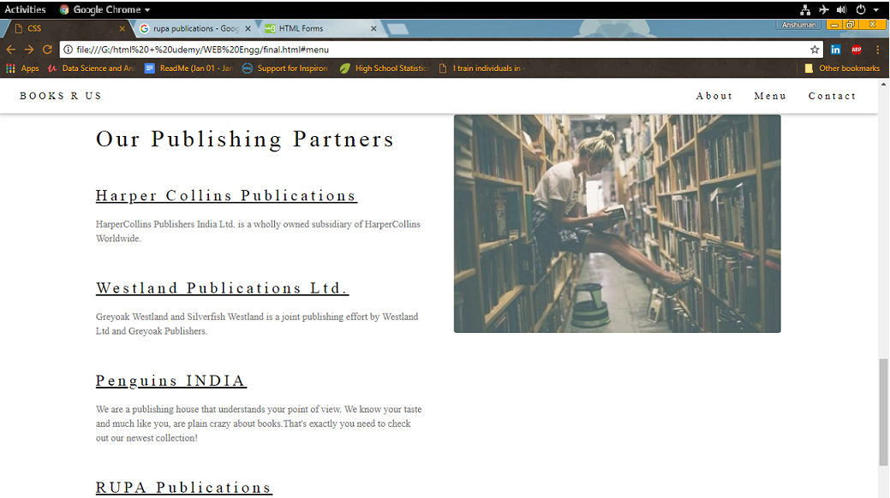

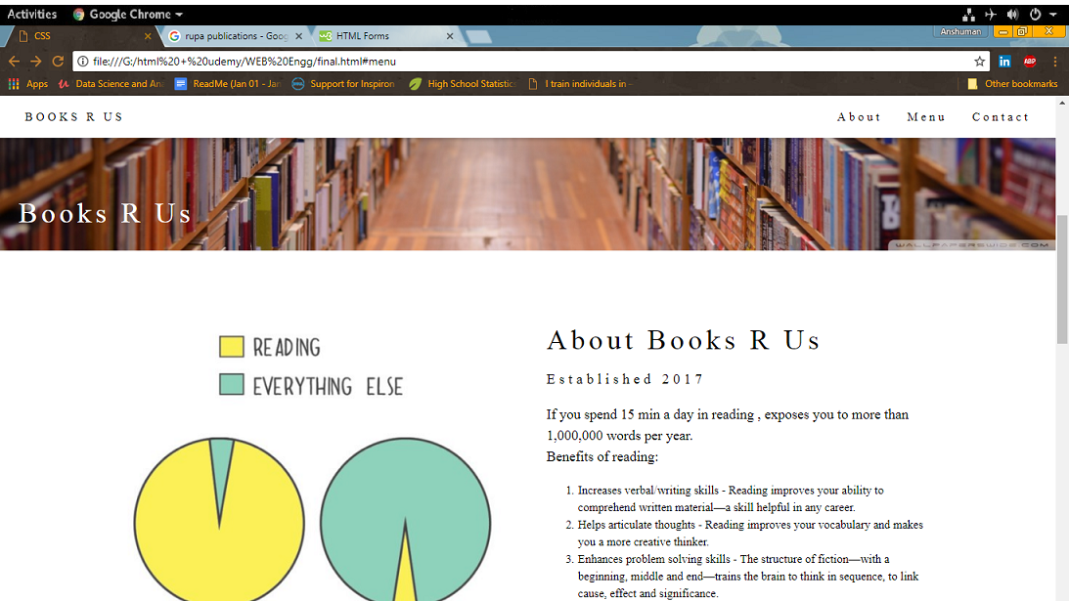

**Experiment: 04**

**AIM : Designing the BOOKS R US website and adding a FORM .**

**Screenshots:**

